To perform the below static checks, locate the following terminals on the drive:
- The + and - terminals usually located between the input and output terminals.
- The R/L1, S/ L2, T/L3 input and U/T1, V/T2, W/T3 output terminals.
Important steps before starting the tests below:
- Remove power to the VFD being tested.
- Disconnect the input and output wires connected to the VFD terminals (make sure the wires are correctly labeled before removing them).
- Ensure the DC bus is completely discharged by measuring between the positive (+) and negative (-) bus terminals with a DC voltmeter set to the highest scale.
- Turn the multimeter dial to Diode Test Mode as shown below:
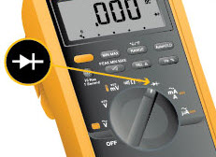
First Step:
- Take the positive multimeter lead and put it on the - terminal of the VFD.
- Take the negative multimeter lead and put it on each input and output terminal of the VFD one at a time.
- If a terminal is good, it should read a voltage drop from 0.299 to 0.675 vdc and consistent reading between all phases.
Step | (+) Positive Multimeter Lead | (-) Negative Multimeter Lead | Multimeter Reading  (Diode Test Mode) | 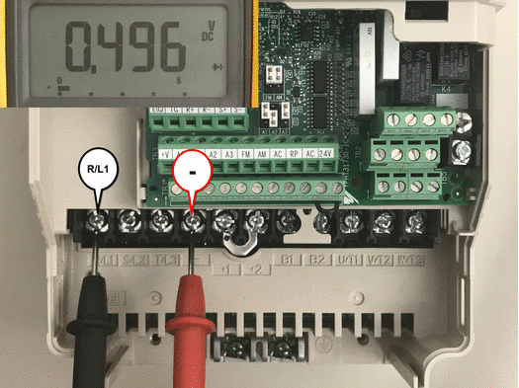
1 | (-) Terminal | R/L1 Terminal  S/L2 Terminal  T/L3 Terminal  U/T1 Terminal  V/T2 Terminal  W/T3 Terminal | 0.299 ~ 0.675 vdc

Second Step:
- Take the negative multimeter lead and put it on the - terminal of the VFD.
- Take the positive multimeter lead and put it on each input and output terminal of the VFD one at a time.
- If a terminal is good, it should return with a OL (open) reading on the meter.
Step | (+) Positive Multimeter Lead | (-) Negative Multimeter Lead | Multimeter Reading  (Diode Test mode) | 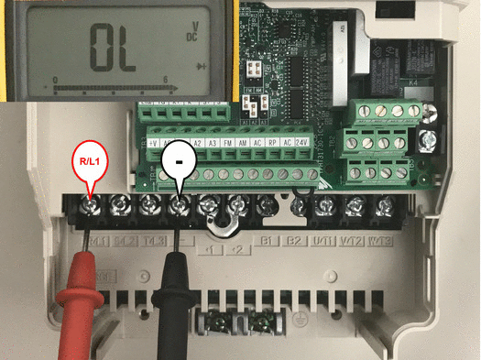
2 | R/L1 Terminal  S/L2 Terminal  T/L3 Terminal  U/T1 Terminal  V/T2 Terminal  W/T3 Terminal | (-) Terminal | OL *
* Note: On larger drives, the multimeter will take longer to reach OL. As long as the multimeter continues to escalate, the diode check is good.
Third Step:
- Take the negative multimeter lead and put it on the DC + terminal.
- Take the positive multimeter lead and put it on each input and output terminal of the VFD.
- If a terminal is good, it should read a voltage drop from 0.299 to 0.675 vdc and consistent reading between all phases.
Step | (+) Positive Multimeter Lead | (-) Negative Multimeter Lead | Multimeter Reading  (Diode Test Mode) | 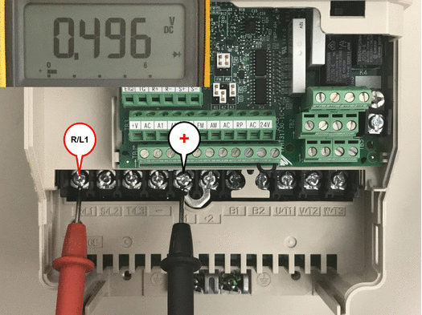
3 | R/L1 Terminal  S/L2 Terminal  T/L3 Terminal  U/T1 Terminal  V/T2 Terminal  W/T3 Terminal | (+) Terminal | 0.299 ~ 0.675 vdc

Fourth Step:
- Take the positive multimeter lead and put it on the DC + terminal.
- Take the negative multimeter lead and put it on each input and output terminal of the VFD.
- If a terminal is good, it should return with a OL (open) reading on the meter.

Step | (+) Positive Multimeter Lead | (-) Negative Multimeter Lead | Multimeter Reading  (Diode Test mode) | 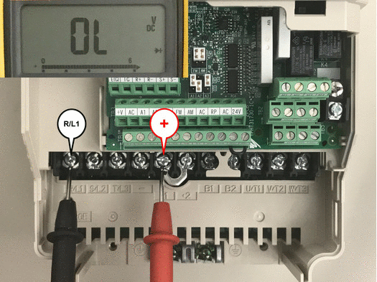
4 | (+) Terminal | R/L1 Terminal  S/L2 Terminal  T/L3 Terminal  U/T1 Terminal  V/T2 Terminal  W/T3 Terminal | OL *
* Note: On larger drives, the multimeter will take longer to reach OL. As long as the multimeter continues to escalate, the diode check is good.
Fifth and Sixth Step (Applicable on drives with built in braking transistor):
- Take the positive multimeter lead and put it on the B1 terminal.
- Take the negative multimeter lead and put it on the B2 terminal.
- If a terminal is good, it should return with a OL (open) reading on the meter.
- Take the positive multimeter lead and put it on the B2 terminal.
- Take the negative multimeter lead and put it on the B1 terminal.
- If a terminal is good, it should read a voltage drop from 0.299 to 0.675 vdc and consistent reading between all phases.
Step | (+) Positive Multimeter Lead | (-) Negative  Multimeter Lead | Multimeter Reading  (Diode Test mode) | 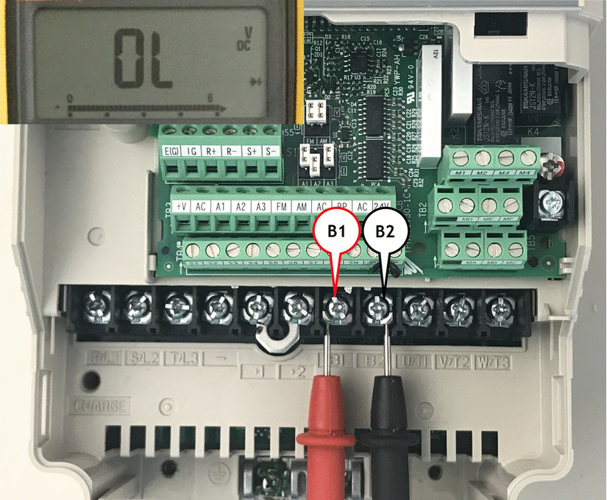
5 | B1 | B2 | OL
6 | B2 | B1 | 0.299 ~ 0.675 vdc

Yaskawa requests that viewers do not embed this video on other online articles or websites. To share this video, share a link to Yaskawa's Solution Center page containing the video.
Meter readings for a bad input diode or output transistor:
- If the meter returns a reading of 0.000 to 0.100, the IGBT is shorted and should be replaced. These readings could result in blowing fuses or further damaging the unit.
Notes:
- Some units may have multiple internal input diodes and output IGBT modules. If one is found to be defective, all should be replaced at the same time.
- When replacing IGBT's Yaskawa recommends also replacing the Gate Drive board.

- If the meter returns a reading of more than 0.750 or a OL when expected to read 0.299 ~ 0.675 vdc, this usually means the rectifier or the output transistor is open which could result in no display at the operator keypad, the loss of an input or output phase.

